Report on Monitoring and Assessment: Ukraine, 2022

1. General Information

1.1 Number of cruises performed for monitoring and assessment of pollution in 2022

During 2022, as a result of hostilities and martial law, standard environmental monitoring within the exclusive maritime economic zone of Ukraine, including the area of the Danube coast and the waters of the open seas, was not conducted.
Therefore, the Report includes the results and studies of the quality of sea waters, bottom sediments in samples that were selected by specialists at two stations of regular integrated monitoring of the water body CW5 in the area of "Cape Maly Fontan" and the beach "Arkadia" before the start of hostilities and at one station in area of the Black Sea Yacht Club of the same body of water starting from June 2022.

1.2 Number of stations (sampling points, maps)
The existing stations network of the ecological monitoring of Black Sea in 2022 included 3 stations. Description of these stations is presented in Table 1.
Locations of the stations are presented in Figure 1.

Table 1 - BSIMAP Stations in 2022
No St. | Name  St. | Latitude | Longitude | Location | Performer
1 | 1 | 46°26.306' | 30°46.350' | Cape M.Fontan | UkrSCES
2 | 1 | 46°25.650' | 30°46.98' | Arcadiya beach | UkrSCES
3 | 1 | 46°27.588' | 30°45.921' | Black Sea Yacht Club | UkrSCES

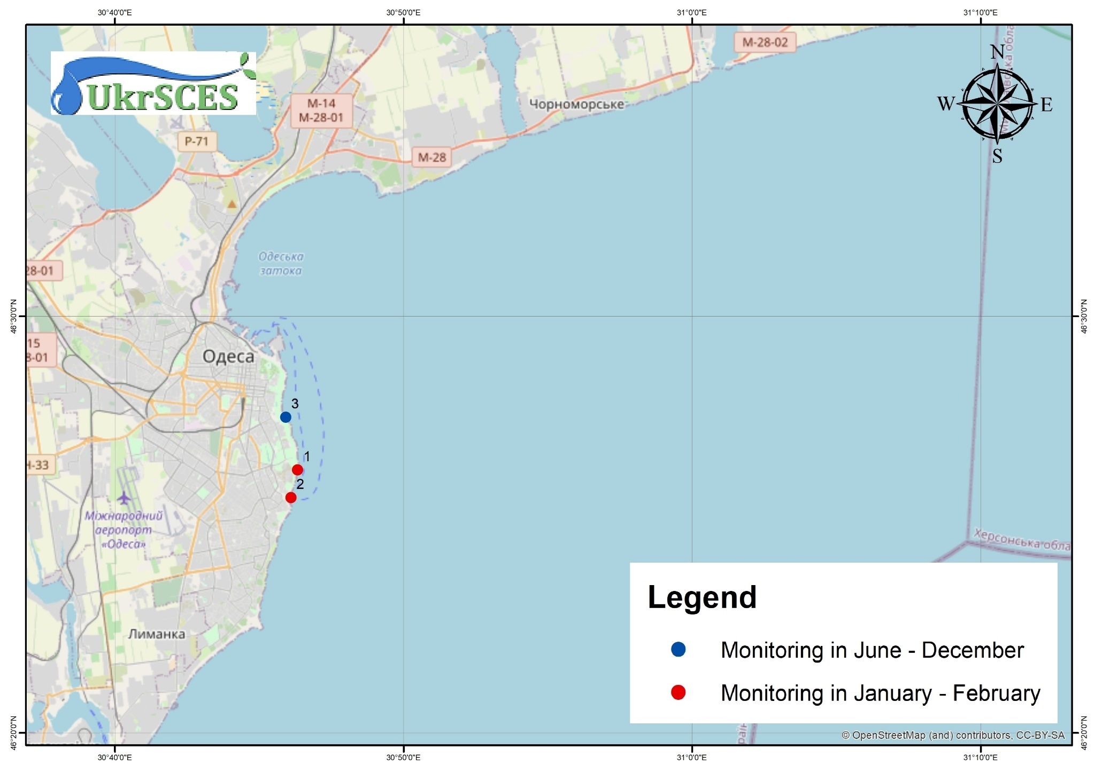
Figure 1 – BSIMAP stations of Ukraine in 2022

1.3 List of monitored parameters

List of monitoring parameters and number of performed samples in comparison with 2021 are presented in Table 2.

Table 2 - Samples numbers of Regional Ukrainian Monitoring Data in 2022/2021
Parameter | Samples numbers  (2021/2020) |  | Parameter | Samples numbers  (2021/2020) | Parameter | Samples numbers  (2021/2020)
Hydrochemicals (water) |  |  | Metals (water) |  | PAHs (water&bs)
Temperature | 31/84 |  | Fe | 5/48 | Naphthalene | 8/27 0/10
Salinity | 25/84 |  | Mn | 0/0 | Acenaphthylene | 8/27 0/10
pH | 31/84 |  | Zn | 5/48 | Fluorene | 8/27 0/10
O₂ | 31/48 |  | Co | 5/48 | Acenaphthene | 8/27 0/10
TSS | 0/48 |  | As | 5/48 | Phenanthrene | 8/27 0/10
Transparency | 0/40 |  | Hg | 5/48 | Anthracene | 8/27 0/10
BOD5 | 31/0 |  | Cu | 5/48 | Fluoranthene | 8/27 0/10
TOC | 0/48 |  | Cd | 5/48 | Pyrene | 8/27 0/10
H₂S | 0/0 |  | Pb | 5/48 | Benzo[a]antracene | 8/27 0/10
P(PO₄) | 31/84 |  | Ni | 5/48 | Chrysene | 8/27 0/10
P_{total} | 31/84 |  | Cr | 5/48 | Benzo(b)fluoranthene | 8/27 0/10
N (NH₄) | 31/84 |  | Al | 0/0 | Benzo(k)fluoranthene | 8/27 0/10
N (NO₂) | 31/84 |  | Other organic pollutants  (water) |  | Benzo[a]pyrene | 8/27 0/10
N (NO₃) | 31/84 |  | Phenols | 0/0 | Dibenzo[a,h]anthracene | 8/27 0/10
N_{total} | 31/84 |  | Detergents | 0/0 | Indeno(1,2,3-c,d)pyrene | 8/27 0/10
SiO₄ | 31/48 |  | TPHs | 0/0 | Benzo(ghi)perylene | 8/27 0/10
Chlororganic pesticides (water&bs) |  |  | PCBs total (water&bs) |  | Metals (bs*)
DDT |  | 8/48 0/24 | Ar1254 | 0/0 0/24 | Zn | 2/24
DDD |  | 8/48 0/24 | Ar1260 | 0/0 0/24 | Co | 2/24
DDE |  | 8/48 0/24 | PCB (37 ind.) | 88/48 0/24 | As | 2/24
Lindane |  | 8/48 0/24 |  |  | Hg | 2/24
α-HCH | 8/48 0/24 |  |  |  | Cu | 2/24
β-HCH | 8/48 0/24 |  |  |  | Cd | 2/24
HCB | 8/48 0/24 |  | Other organic pollutants (bs) |  | Pb | 2/24
Heptachlor | 8/48 0/24 |  | Phenols | 0/24 | Ni | 2/24
Aldrin | 8/48 0/24 |  | TPHs | 0/24 | Al | 2/24
Dieldrin | 8/48 0/24 |  | TOC | 0/24 | Fe | 2/24
Endrin | 0/0 0/0 |  |  |  | Cr | 2/24
* bs – bottom sediments

1.4 National institutions (laboratories) involved

- UkrSCES - the Ukrainian Scientific Centre of Ecology of the Sea, Ministry of the Environment Protection (Department of Analytical Research and Organization of Monitoring, head Yuriy Denga)

1.5 Data were reported to the Ministry of environmental protection and natural resources of Ukraine, Permanent Secretariat of the BSC.

1.6 Financing assured by Ministry of environmental protection and natural resources of Ukraine

Summary of quality control procedures routinely employed within the laboratory:

- Use of high quality analytical standards for instrument calibration.
- Use of high quality glassware, acids and other reagent and equipment.
- Routine calibration and adjustments of AAS and maintains of continuous records of these calibrations.
- Routine performance tests including complete procedural blank analyses and spikes.
- Use of certified reference material and performance of quality control chart.
- Use of replicate samples.
- Participation in Proficiency testing exercises

1.7 Names of authors of the annual report provided and names of those providing data:

Y. Denga, V. Komorin, Y. Oleinik, I. Tretyak, O. Miasnikova, O. Leposhkin, A. Titiapkyn

1.8 Participation in international conferences, seminars and meetings in 2022:

Research staff of UkrSCES participated in conferences, symposiums and workshops, a large part of which, due to the long quarantine and martial law, took place online:
- Marine mammal necropsy training course, ACCOBAMS, February 21-25, 2022, Padua (Italy).
- ZOOM – EMODnet Biology conference "Annual meeting" May 4-5, 2022.
- ZOOM - webinar on communications and dissemination of information BRIDGE-BS project (work package 9), May 12, 2022.
- Meeting at the Odesa Regional Military Administration regarding actions to prevent man-made accidents as a result of missile attacks, May 21-24, 2022.
- International scientific conference "ISBER-2022 (International Society for Biological and Environmental Repositories)", June 12-14, 2022.
- ZOOM - open seminars "Ecological monitoring in the Black Sea basin using products of the Copernicus program (PONTOS), July 20-21, 2022
- ZOOM - the second training "Earth Remote Sensing and Environmental Monitoring for Young Scientists and Practitioners" under the project "Environmental Monitoring in the Black Sea Basin Using Products of the Copernicus Program" (PONTOS), July 26-27, 2022.
- International scientific and practical conference "24th Biennial Conference of the Society for Marine Mammalogy", USA, August 1-5, 2022.
- International scientific conference "ACCOBAMS workshops on Data Collection on Cetacean Population Genetics in the ACCOBAMS area" (Monaco, September 2-21, 2022).
- ZOOM - webinar "The EGI-ACE webODV - Online extraction, analysis and visualization of SeaDataNet and Argo data" - extraction, analysis and visualization of SeaDataNet and Argo data, November 4, 2022.
- International scientific and practical conference "Plastic pollution from macro to nano MICRO2022. November 14-18, 2022 with a poster presentation "The Cruise of three European Seas of RV Belgica/Boris Aleksandrov – Microplastics in seabed sediment and surface waters – including a comparison of devices for surface water sampling."
- International scientific and practical conference "XXIInd International Multidisciplinary Scientific GeoConference Surveying, Geology and Mining, Ecology and Management - SGEM 2022".
- Participation in the meeting of the working group on the Joint Maritime Agenda for the Black Sea (JMA) in Brussels (Kingdom of Belgium) from December 12 to 17, 2022.

1.9 Publications in 2022

1. Зайченко М.Д., Тітяпкин А.С., Український В.В. Огляд продуктів служби моніторингу морського середовища Copernicus для оцінки стану та якості вод Чорного моря за показниками евтрофованості // Матеріали Четвертої Всеукраїнської науково-практичної конференції «Євроінтеграція екологічної політики України». Одеса: Одеський державний екологічний університет, 25.10.2022,– С. 187-193.
2. Полежаєв Є.К., Тітяпкин А.С. Просторово-часова мінливість температури поверхневого шару води Чорного та Азовського морів // Вісник Гідрометцентру Чорного та Азовського морів. Державна гідрометеорологічна служба України. – 2021/2022. – № 1(25). – Мови: укр., рос. – С. 152-161.
3. Попов Ю.І. Деякі зауваження щодо якості даних буїв-провілемерів ARGO, що працюють у басейні Чорного моря //Вісник Гідрометцентру Чорного та Азовського морів. Державна гідрометеорологічна служба України. – 2021/2022. – № 1(25). – Мови: укр., рос. – С. 144-152.
4. Ю. С. Тучковенко, О. П. Гаркуша, О. М. Гриб, С. Г. Гуща, Ю. М. Деньга, К. С. Калашнік, Х. О. Коєва, В. М. Коморін, О. В. Кошелев, Г. Г. Мінічева, Н. С. Лобода, А. Л. Погребний, Ю. В. Олейнік, С. М. Степаненко, О. І. Цуркан. «Результати гідрологічного, гідрохімічного, гідробіологічного та медико-біологічного обстеження Куяльницького лиману». «Український гідрометеорологічний журнал, Океанологія та морське природокористування. 2022, - 30, р.
5. Gol’din P., Vertsimakha O., Ghazali M., Dzeverin I., Vishnyakova K., Telizhenko V., Davydenko S., Ortiazhyi P. Anatomical network as a tool for studies of evolution of marine mammal skeleton // Marine mammal research and conservation effort – Are we on the right path? 33rd Conference of the European Cetacean Society. 5th to 7th April 2022, Ashdod, Israel. [Abstract book]. – Studio Orna Cohen, 2022. – P. 109.
6 Yu H., Jamieson A., Hulme-Beaman A., Conroy C. J., Knight B., Speller C., Al-Jarah H., Eager H., Trinks A., Adikari G., Baron H., Böhlendorf-Arslan B., Bohingamuwa W., Crowther A., Cucchi T., Esser K., Fleisher J., Gidney L., Gladilina E., Gol’din P., Goodman S. M., Hamilton-Dyer S., Helm R., Hillman C., Kallala N., Kivikero H., Kovács Z. E., Kunst G. K., Kyselý R., Linderholm A., Maraoui-Telmini B., Morales-Muñiz A., Nabais M., O'Connor T., Oueslati T., Quintana Morales E. M., Pasda K., Perera J., Perera N., Radbauer S., Ramon J., Rannamäe E., Grego J. S., Treasure E., Valenzuela-Lamas S., Van der Jagt I., Van Neer W., Vigne J.-D., Walker T., Wynne-Jones S., Zeiler J., Dobney K., Boivin N., Searle J. B., Krause-Kyora B., Krause J., Larson G., Orton D. 2022. Palaeogenomic analysis of black rat (Rattus rattus) reveals multiple European introductions associated with human economic history //Nature Communications 13, 2399. https://doi.org/10.1038/s41467-022-30009-z (Wos/Scopus, Q1, IF 17.7)
7. Dewaele L., Gol’din P., Marx F. G., Lambert O., Laurin M., Obadă T., & de Buffrénil V. 2022. Hypersalinity drives convergent bone mass increases in Miocene marine mammals from the Paratethys // Current Biology 32(1): 248-255.e2 https://doi.org/10.1016/j.cub.2021.10.065 (Wos/Scopus, Q1, IF 10.9)
8. Telizhenko V., McGowen M., Gol’din P. Evolution of HOXD13 gene in cetaceans shows lifting selective constraints for limb patterning // 24th Biennial Conference of the Society for Marine Mammalogy. Palm Beach, Florida. 1-5 August 2022. – P. 221-222.
9. Komorin V., Dikhanov Yu., Bolshakov V., Popov Yu., & Matsokin L. (2022). Variability of the oceanographic structures of the Southern Ocean by the FerryBox data. Ukrainian Antarctic Journal, 20(1), 44—54. https://doi.org/10.33275/1727-7485.1.2022.688
10. Kuzmina T. A., Salganskij O. O., Vishnyakova K. O., Ivanchikova J., Lisitsyna O. I., Korol E. M., Kuzmin Yu. I. Helminth diversity in teleost fishes from the South Orkney Islands Region, West Antarctica, Zoodiversity, 56(2):135–152, 2022 DOI 10.15407/zoo2022.02.135 ((Scopus, Q3)
11. Popov D., Gol’din P., Meshkova G., Vishnyakova K., Ivanchikova J., Paiu M., Timofte C., Öztürk A., Tonay A., Panayotova M., Düzgüneş E. Assessment of bycatch level for the Black Sea harbour porpoise in the light of new data on population abundance // Marine mammal research and conservation effort – Are we on the right path? 33rd Conference of the European Cetacean Society. 5th to 7th April 2022, Ashdod, Israel. [Abstract book]. – Studio Orna Cohen, 2022. – P. 72.
12. Nabokin M. Faunistic analysis of freshwater zooplankton in small rock pools of Maritime Antarctica. Ukrainian Antarctic journal, 2022, 20.1 (24): 113-124. https://doi.org/10.33275/1727-7485.1.2022.694
13. Madina Lucia Dolle, Paulina Hübner, Georg Hanke, Luis Ruiz, Jaroslav Slobodnik, Peter Oswald, Viktor Komorin, Yurii Oleinik, Mykhailo Nabokin, Andrii Zotov and Elke Kerstin Fischer. The Cruise of three European Seas of RV Belgica/Boris Aleksandrov – Microplastics in seabed sediment and surface waters – including a comparison of devices for surface water sampling. 14-18 November 2022 International conference Plastic pollution from macro to nano MICRO2022. Poster presentation. 2022. https://doi.org/10.5281/zenodo.7216980.
14. Nabokin M.; Gorobchyshyn V.; Trokhymets V.; Salganskiy O.; Kovalenko P.; Tkachenko V.; Svetlichniy L.; Kozeretska, I. Distribution of Boeckella poppei (Mrázek, 1901) (Anostraca: Copepoda) in freshwater rock pools of Antarctic Argentine islands. Ukrainian Antarctic journal, 2022, 20.2 (25) (in press)
15. D. Gonzalez-Fernandez, G. Hanke, M. Pogojeva, N. Machitadze, Y. Kotelnikova, I. Tretiak, O. Savenko, K. Bilashvili, N. Gelashvili, A. Fedorov, D. Kulagin, A. Terentiev,J. Slobodnik. Floating marine macro litter in the Black Sea: Toward baselines for large scale assessment. Environmental Pollution, 2022, 309: 119816. https://doi.org/10.1016/j.envpol.2022.119816
16. Terenko G.; Krakhmalnyi A. Red tide of Lingulodinium polyedrum (Dinophyceae) in Odesa Bay (Black Sea). Turkish Journal of Fisheries and Aquatic Sciences, 2021, 22.4. http://doi.org/10.4194/TRJFAS20312
17. Chuzhekova T., Iakymenko G., Pochaievets O., Ahmed A. Sustainable land-use along the Mertvovid River (southern Ukraine). XXIInd International Multidisciplinary Scientific GeoConference Surveying, Geology and Mining, Ecology and Management – SGEM 2022. Poster presentation.
2 State of the Environment

Climate change in recent decades has exacerbated the negative environmental manifestations of anthropogenic impact on the marine environment. First of all, this applies to the northwestern part of the Black Sea (NWP of BS).
Climate change is more evident in both the increase in air temperature and the temperature of sea water, which is especially noticeable in the example of the NWPBS since the 90s of the last century (Figure 2.1).
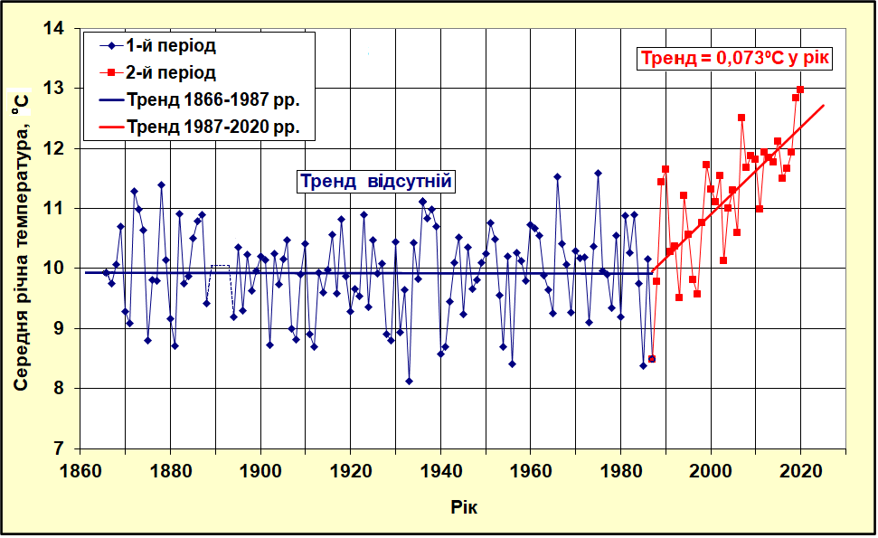
a) b)
Figure 2.1 – Long-term variability of the average annual air temperature at the NWP of BS (a) and temperature of sea water (b) according to the data of long-term observations of the Odesa-port HMS (hydrometeorological service).

In 2022, the average water temperature, according to the Odesa-port HMS, was 12.0 ºC, the air temperature was 12.2 ºC. Over the past ten years, as a result of this trend, the duration of the ice period has decreased by 1.5-3 decades. The last time ice was observed off the coast of Odesa, according to the observations of the Odesa-Port HMS, was in February 2018.
2022, with a rainfall of 292 mm, was the first dry year in 77 years since 1944. In 2022, 293 mm of precipitation fell with a norm of 462 mm.
The salinity regime of surface waters, especially on the shallow shelf, is significantly influenced by river runoff, precipitation, temperature and wind regimes, which form the circulation and transport of water. The linear trend in Figure 2.2 shows an increase in salinity at a rate of 0.02 ops per year.
Figure – 2.2 - Variability of salinity in the XXI century according to observations of the station "Odesa – port".

The average salinity of seawater according to the Odesa-port HMS in 2022 was 14.66 ops. with a thirty-year norm of 13.95 ops. This increase in salinity may be due to a decrease in the flow of the main rivers flowing into the NWP of BS. Thus, the flow of the Danube was 145.2 km3 against the norm of 203 km3, and the total volume of the flow of the main rivers of the Black Sea has decreased by about 44–45 km3 over the past 20 years. Such conditions lead to changes in the hydrophysical and hydrochemical regime of waters, which, in turn, significantly affect the state of marine ecosystems.

3 POLLUTIONS of marine environment

To assess the ecological state by the content of pollutants in 2022, the pollution coefficient (Kz) was used, which reflects the concentration of all pollutants in a certain period of time in a given area and is calculated as the sum of the ratios of the concentration of each pollutant to its maximum permissible concentration.
The scale of assessment of the ecological state of sea water in coastal water massifs according to the Cr of the "Marine Environmental Strategy of Ukraine" is divided into five classes (Table 3.1).

Table 3.1 – Quality status of coastal water bodies by pollutant content
Quality status of water bodies | The pollution coefficient (Kz) in seawater | Quality status in color coding
Very good | ≤0,5
Good | >0,5 to ≤1,0
Satisfactory | >1,0 to ≤2,5
Bad | >2, 5 to ≤5,0
Very bad | >5,0

According to the results of seawater studies in 2022:
- the content of all HMs in the coastal waters of the Odessa Bay (CW5 Area) was small, and the status corresponded to the "Very good" ecological condition.
- seawater pollution in the area of the CW5 by organic pollutants of agricultural origin (OPAO) ranged from "very good" to "very bad".
- assessment of the ecological state of seawater by Kz organic pollutants of industrial origin (OPIO) showed that it corresponded to "very bad".
Table 3.2 presents the Kz values for mercury (Hg), cadmium (Cd), lead (Pb), nickel (Ni) and the Kz values in general for TM in the surface layer of water. The environmental assessment was carried out in accordance with EU Directive 2013/39/EU (MAC-EQS).

Table 3.2 – Ecological state of coastal water massifs according to the indicator of Kz TM of sea water by districts in 2022.
Area | Layer | Кз ТМ | Кз Cd | Кз Hg | Кз Pb | Кз Ni | Quality status
TW5 | surface | 0,068 | 0,03 | 0,18 | 0,05 | 0,01 | Very good

The total characteristics of the ecological state of the water body are given according to the indicators of Kz provided for their worst indicator. The ecological state corresponds to the GES.
In terms of TM group contamination, the largest contribution in the study area falls on the concentration of mercury, followed by the concentration of lead (Fig. 3.1).

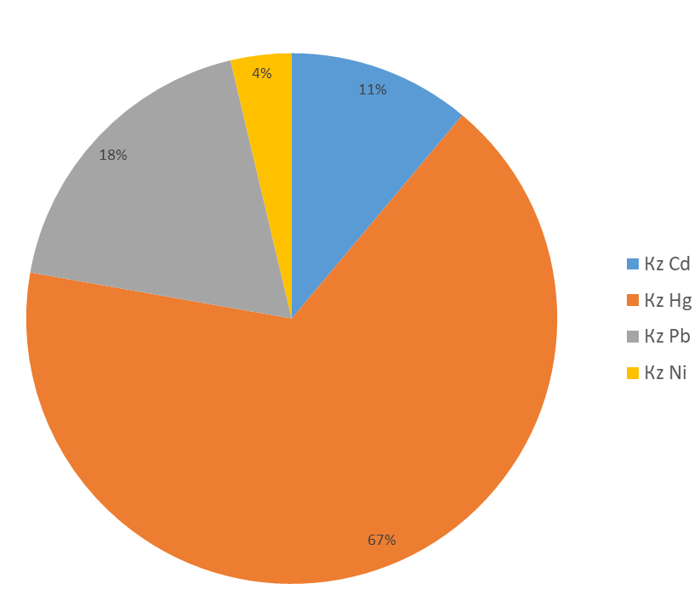
Figure 3.1 – Contribution of Kz of individual metals to seawater pollution by region in 2022

Table 3.3 show Kz for individual OPAOs and the average Kz for OPAOs in the surface and bottom layer of water according to 2021 data by district. The environmental assessment was carried out in accordance with EU directive 2013/39/EU (MAC-EQS).

Table 3.3 Kz OPAOs of the surface and bottom layer of sea water in 2021
Area | layer | Кz ОPAO | Кz DDT¹ | Кz ∑DDT² |  | Кz ∑HCH³ | Кz HCB⁴ | Кz heptachlor | Кz ∑ cyclodiene⁵ | Кz Atrazine | Кz Dyrsban | Quality status
CW5 | surface | 1,37 | 0,13 | 0,12 |  | 0,06 | 0,01 | 10,21 | 0,4 | 0 | 0,01 | Satisfactory
1 – p,p-dichlorodiphenyltrichloroethane  2 – sum DDT and its metabolites  3 – the sum of lindane and its isomers |  |  |  |  | 4 – hexachlorobenzene  5 – sum of aldrin, dieldrin and endrin

According to the indicators of the OPAO group, the largest contribution in the area of CW5 in the surface layer of water is made by the concentration of heptachlor (Fig. 3.2).

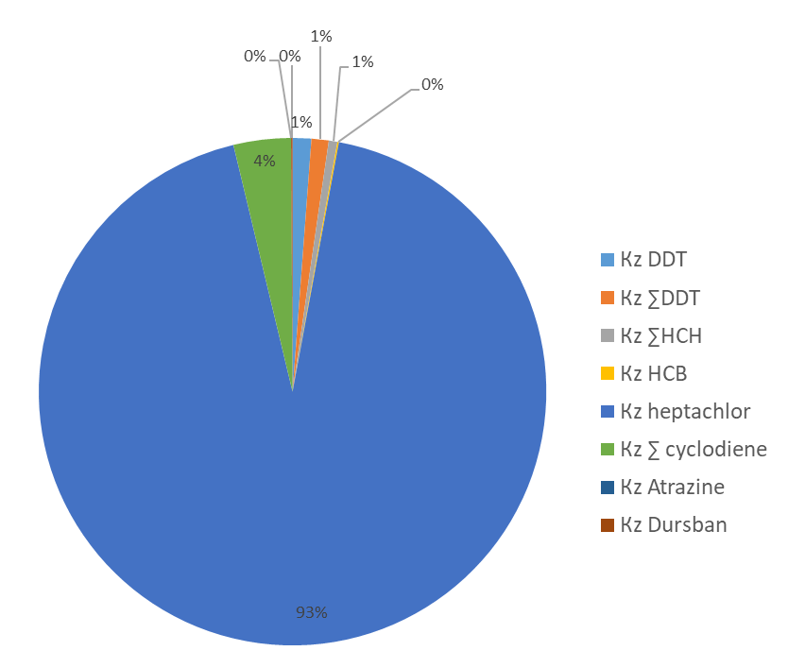
Figure 3.2 - Kz OPAOs of sea water by regions in 2022
Table 3.4 presents the values of Kz for individual OPIO and the average Kz for OPIO.
The ecological state of coastal water bodies was most affected by the concentrations of individual PCBs 101, 118, 153, 138, 180 (Figure 3.3), their Kz value significantly exceeds the threshold level >5.0 of the "bad" ecological state.
Also, increased concentrations were recorded in the surface layer by the Kz of naphthalene, which corresponds to a "satisfactory" ecological state. Since Directive 2013/39/EU (MAC-EQS) has no restrictions on the concentrations of polychlorinated biphenyls (PCBs) in water, the maximum permissible concentrations for PCBs were taken from the recommendations of EAC, OSPAR SIME 2008. Kz indicators of polyaromatic hydrocarbons (PAHs) were calculated in accordance with the data of Directive 2013/39/EU (MAC-EQS).

Table 3.4 Kz OPIOs of the surface layer of sea water in 2022.
Area | layer | Кz ОPIO | Кz PCB 101 | Кz PCB 118 | Кz PCB 153 | Кz PCB 138 | Кz PCB 180 | Кz naphthalene | Кz anthracene | Кz fluoranthene | Кz benzo(b)fluoranthene | Кz benzo(k)fluoranthene | Кz benzo(a)pyrene | Kz benzo(g,h,i)perylene | Quality status
CW5 | surface | 24,6 | 128 | 29,0 | 166 | 96,1 | 83,6 | 1,45 | 0,59 | 0 | 0,04 | 0,02 | 0,01 | 0,01 | Bad

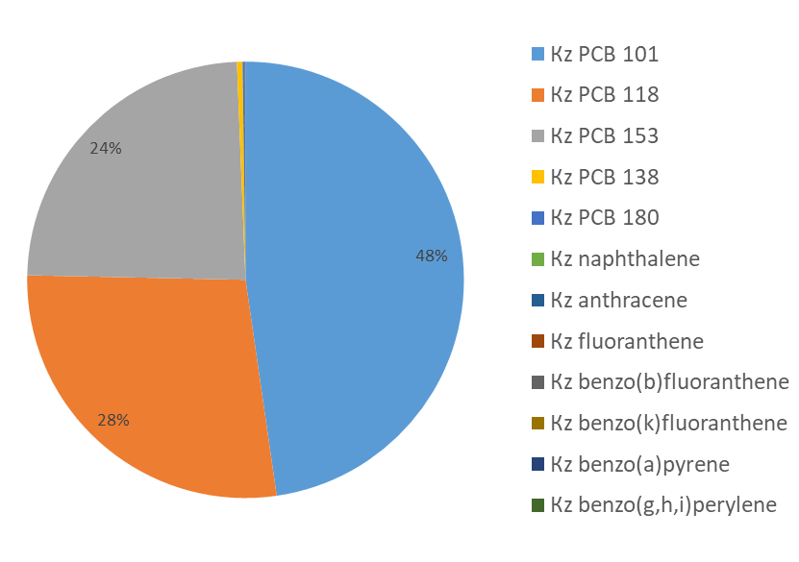
Figure 3.3 - Kz OPIOs of sea water by regions in 2022

The total content of individual PAHs (∑ PAHs), benzo(a)pyrene equivalent (B(a)Peq) and the sum of carcinogenic PAHs (∑ carc PAHs) were at a low level (Table 3.5).

Table 3.5 Sum of PAHs, benzo(a)perene equivalent and sum of carcinogenic PAHs of the surface layer of sea water in 2022.
Area | Ʃ PAHs | B(a)Peq | Σ carc PAHs
Area | surface layer of water
CW5 | 36,2 | 0,35 | 0,48

The results of studies of the amount of HB in the coastal waters of the Odessa Bay showed an excess of the maximum permissible concentration (0.05 mg/dm3) in July, September and October (Table 3.6).

Table 3.6 – Concentration of petroleum hydrocarbons in the coastal waters of the Odessa Gulf in 2022
Parameter | 13.07.2022 | 27.07.2022 | 17.08.2022 | 25.08.2022 | 07.09.2022 | 14.10.2022 | 16.11.2022 | 14.12.2022
Petroleum hydrocarbons, mg/l | 0,07 | 0,05 | ≤0,03 | 0,04 | 0,08 | 0,06 | 0,04 | 0,04

Since the ecological state of the Black Sea Region is significantly affected by the conduct of hostilities, additional studies of specific weapons are required to assess the consequences of the war.

4 ASSESSMENTS of biodiversity and coastal communities of the North-West Black Sea region

Introduction
The state of marine biocenoses is determined by indicators of general biodiversity, taxonomic and species richness of planktonic and benthic organisms, as well as quantitative characteristics of indicator species. A particularly high diversity of hydrobionts is observed in coastal areas at shallow depths.

Phytoplankton.
During 2022, 169 species and varieties of microalgae belonging to 12 systematic divisions were noted in the phytoplankton of the coastal water bodies of the Odesa region: Bacillariophyceae – 54 (49,5%), Di-nophyceae – 25 (22,9%), Cyanophyceae – 14 (12,8%), Chlorophyceae – 6 (5,5%) and other – 18 (16,5%) (Figure 4.1).

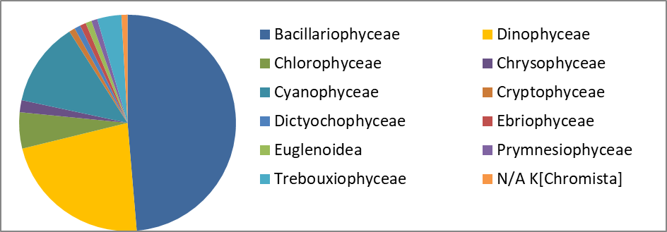
Figure 4.1 – Taxonomic diversity of microalgae at stations in the Odesa region in 2022

In winter, diatoms mostly dominated (74%). In June, when the salinity of water decreased, the proportion of cyanobacteria, green, golden, euglenic and other freshwater algae reached almost 40%. In July and August, diatom blooms were observed. In autumn, storms began and probably significant inflows of fresh water, which caused the appearance of freshwater species, mostly cyanobacteria (between 16 and 37.6%).

Shannon's species diversity index ranged from 0.24 bits • ecs-1 to 3.8 bits • ecf-1, with an average of 2.16 bits • ecf-1, slightly higher than last year's values. The highest values were observed in September and were probably caused by the sharp mixing of large masses of water from different regions of the sea. The lowest values of the species diversity index were in August during the "bloom" of the diatom S. costatum.
Criteria for assessing the ecological state of the water area by phytoplankton biomass are presented in Table. 4.1.
Table 4.1 – Scale for assessing the ecological state of the marine environment by indicators of phytoplankton biomass in the coastal zone of the Ukrainian part of the Black Sea
 | Very good | Good | Satisfactory | Bad | Very bad
winter | <1100 | 1100-1400 | 1400-2000 | 2000-4000 | >4000
spring | <1400 | 1400-1700 | 7400-2500 | 2500-4700 | >4700
summer | <1100 | 1100-1400 | 1400-2000 | 2000-4000 | >4000
autumn | <1000 | 1000-1250 | 1250-1850 | 1850-3700 | >3700

In general, according to the criterion of total phytoplankton biomass, the state of the Odessa region can be assessed as "good".
Zooplankton.
During 2022, 47 taxa of marine and brackish water complexes were identified. The diversity was based on copepods (21 taxa), but mostly due to bento-pelagic species of the orders Harpacticoida and Canueloida. The orders Calanoida and Cyclo-poida were represented by 7 taxa. Meroplankton was diverse – 9 taxa. Cladocerae were represented by 3 taxa (Fig. 4.2).
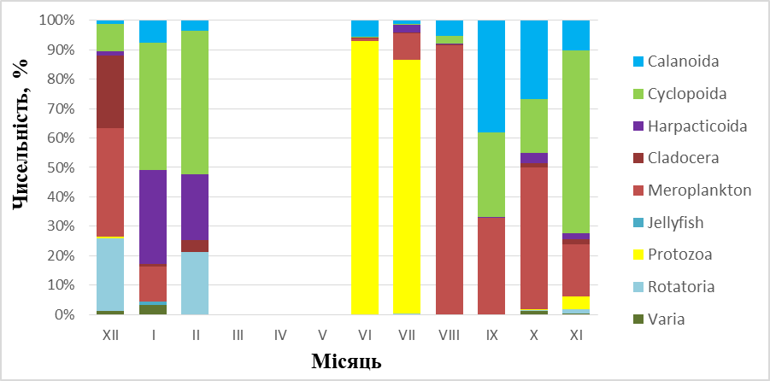
Figure 4.2 – Taxonomic diversity of mesozooplankton in the coastal waters of the Odessa Gulf in 2022

The abundance and biomass of zooplankton on average for the year were slightly higher than last year. The Shannon Index's diversity score was lower in 2022. This year, there was a case of mass development of heterotrophic dinoflagellate Noctiluca scintillans, which may indicate an increase in the level of eutrophication. The first maximum development of zooplankton, which traditionally occurs in spring, shifted to the second half of summer in 2022, which is why it practically merged with the autumn one. This may be due to climate change and a later hydrological spring.
In general, the water area does not meet the criteria of the GES for zooplankton.

Macrozoobenthos
The most important role in the formation of the qualitative composition of macrozoobenthos in 2022 was played by Annelida – 11 taxa, Arthopoda – 10 and Mollusca – 7 taxa (Fig. 4.3).

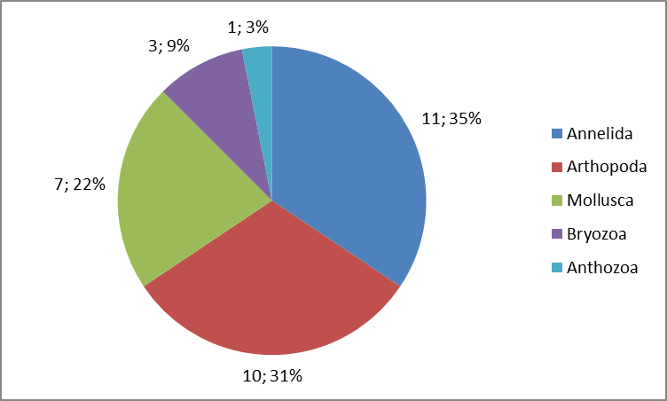
Figure 4.3. – Taxonomic composition of macrozoobenthos in the coastal
waters of the Odessa Bay in 2022

In 2022, 43% of the samples tested met the GES criteria, which is higher than last year.

Macrophytobenthos.
Within the macrophytobenthos, 23 species of macrophytes were identified, which were included in three divisions: Chlorophyta, Rhodophyta and Tracheophyta. The percentage of green and red species is 43.5% (10 species), flowering plants are 13% (3 species). In terms of percentage and biomass, green algae dominated. Seagrasses in summer and red algae in autumn were also numerous. In general, the studied water area is in a depressed state with low diversity. In terms of the number of species, mesosap robes predominate, which indicates moderate pollution of the water area. According to the morphofunctional indicators of macrophytobenthos, the water area corresponds to the "average" ecological state, which does not meet the criteria of the GES.

Microphytobenthos.
174 species of microalgae were found in the microphytobenthos of the studied water areas. Among them, diatoms prevailed – 124 species, or 71.3% of the total number found. The species composition was formed mainly by poly- and mesohalobic and β-mesosaprobic diatoms. Cyanoprokaryotes, green algae, and dinophyte algae were less common. The number of microphytes was formed mainly by small-celled blue-green algae, biomass by large-celled diatoms, mainly poly- and mesohalobes and β-mesosaprobes. In general, the water area showed moderate pollution, as indicated by the dominance of β-mesosaprobes.

5. Eutrophication

The range of variations in the content of nutrients in the region CW5 of national waters of Ukraine in 2022 is presented in the figures (Fig. 5.1 – 5.4).

According to long-term observations in 2000-2021 in the coastal water body СW5 of the Odessa region of the Black Sea there is a tendency to decrease the mineral (DIP) and total phosphorus (TP). The average annual content of mineral phosphorus in this period varied from 23,9 μg/dm³, at the beginning of the XXI century, to 9,3 μg/dm³ in 2015 (Fig. 5.1). In the last five years, the average annual content of mineral phosphorus in coastal waters in this area has ranged from 10,6 μg/dm³ to 13,5 μg dm³, with an average of 12,0 μg/dm³. The level of average annual values of the concentration of mineral phosphorus in the recreational zone of the water body СW5 corresponds to a good ecological condition at the value of GES 16,4 μg/dm³.

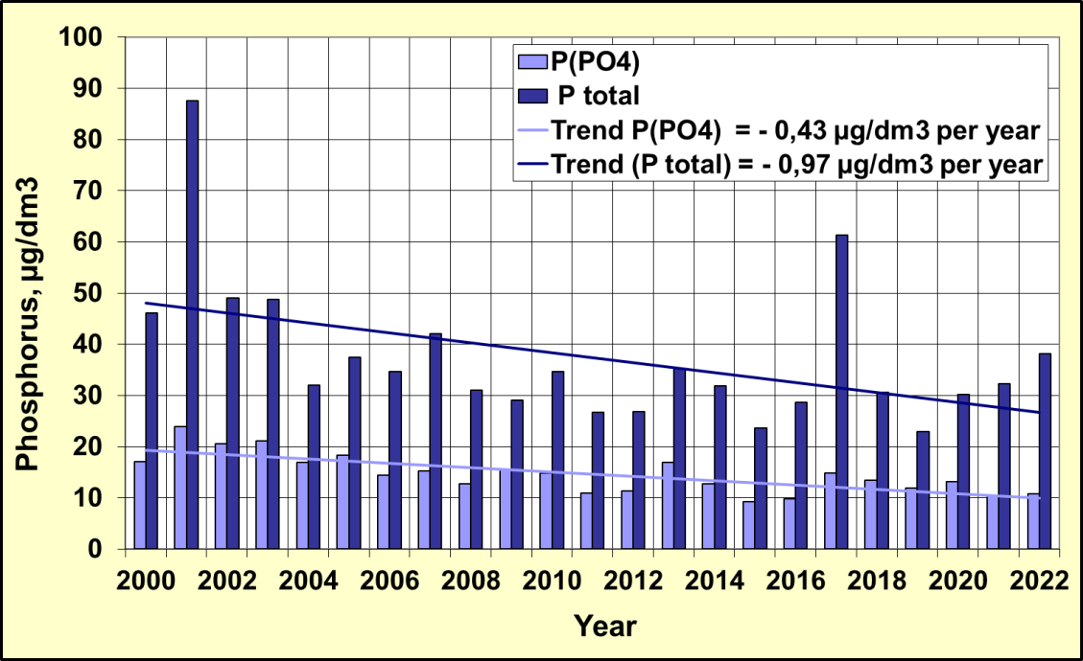
Figure 5.1 - Long-term changes in the content of mineral and total phosphorus in the coastal water body CW5 in the recreational zone of the city of Odessa

In the multi-year plan of 2000 - 2021, the content of the average annual amount of mineral forms of nitrogen (DIN) in the coastal water body СW5 of the Black Sea shows a tendency to decrease its concentration from 182,9 μg/dm³ in 2001 to 47,7 μg/dm³ in 2020. (Fig. 5.2). In the last five years, the average annual mineral nitrogen (DIN) content ranged from 47,7 μg/dm³ to 132,3 μg/dm³, with an average value of 81,5 μg/dm³. In 2021, according to the average annual DIN concentration, coastal waters in this area not corresponded to GES 52,7 μg/dm³. The general tendency to decrease the DIN content in the period 2000 - 2022 was -2,54 μg/dm³ per year.

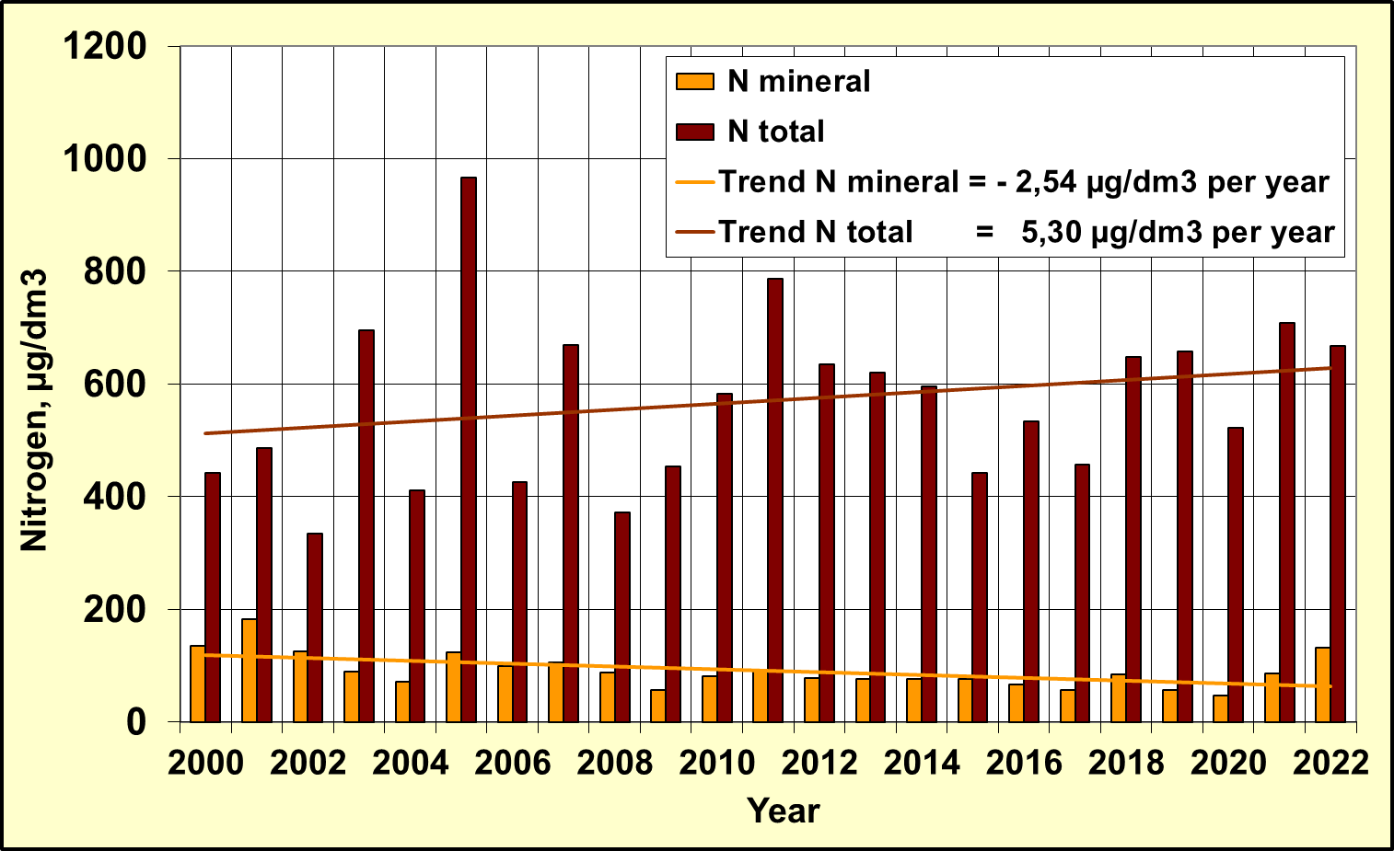
Figure 5.2 - Long-term changes in mineral and total nitrogen content
in the coastal water body СW5 in the recreational zone of the city of Odessa

The tendency to decrease the content of mineral compounds of nitrogen is determined by its individual indicators of nitrite, nitrate and ammonium nitrogen, which is shown in Figure 5.3.

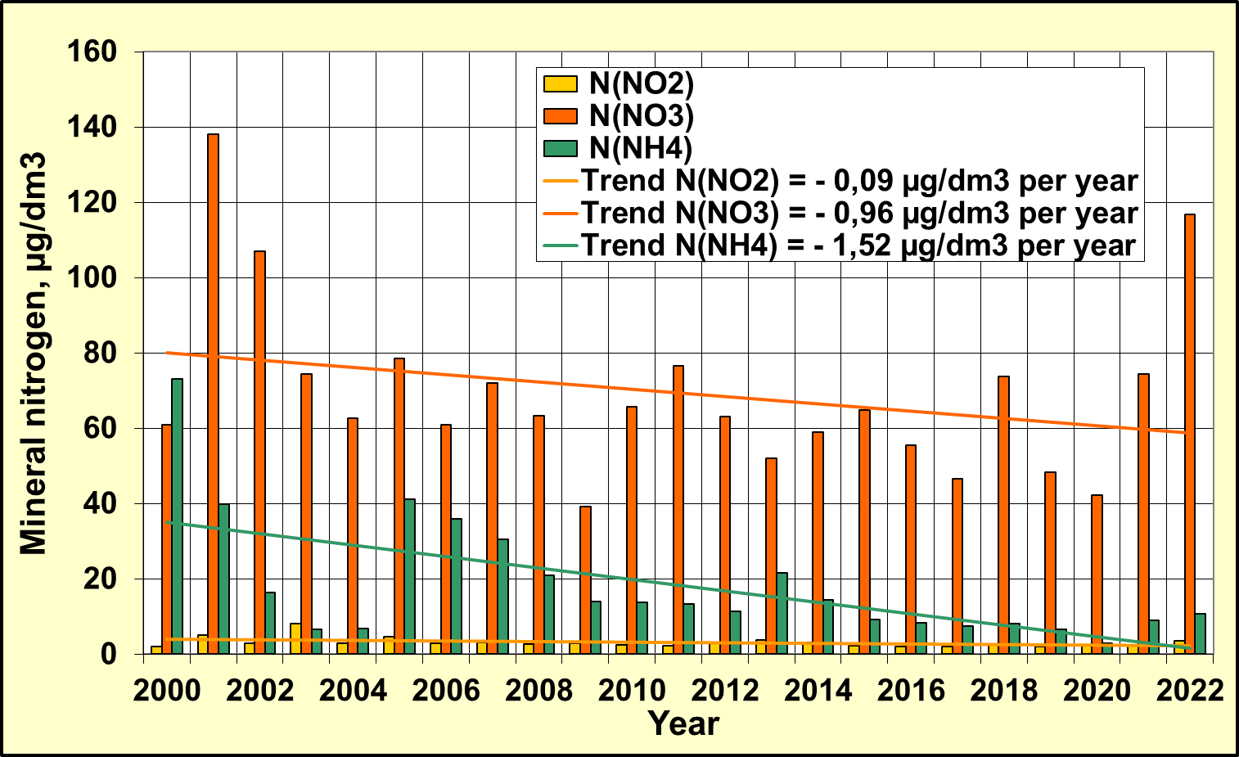
Figure 5.3 - Long-term changes in the content of mineral forms of nitrogen in the coastal water body СW5 in the recreational zone of the city of Odessa

In the long-term variability of biogenic substances, according to the data of regular observations in the coastal waters of the Odesa region since the beginning of 2000, there was a trend towards a decrease in the average annual concentration of phosphate and total phosphorus, mineral forms of nitrogen and, accordingly, a decrease in the trophicity of the coastal waters of the CW5 massif in the period 2000-2015. In 2015-2022, the stabilization of the trophicity of the waters of the CW5 massif is observed at the level of 4.52 units. up to 5.14 units and corresponds to the "average" level of trophicity with the value of the average TRIX index = 4.88 units, which is shown in Figure 5.4.

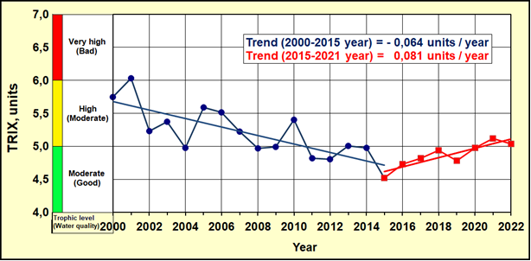
Figure 5.4 – The long-term changes of trophicity and quality of the coastal waters
of Odessa region of NWBS by TRIX index

6. Other activities of the RAC PMA

6.1 Overview of monitoring data flows to the RDB-P by Ukraine in 2022 years

Table 6.1 Statistics of the sample types by years
 |  | 2010 | 2011 | 2012 | 2013 | 2014 | 2015 | 2016 | 2017 | 2018 | 2019 | 2020 | 2021 | 2022
Ukraine | BathingWater | - | - | - | - | - | - | - | - | - | - | - | - | -
Ukraine | Biota | - | - | + | + | + | + | + | + | + | + | + | - | -
Ukraine | Sediment | + | + | + | + | + | + | + | + | + | + | + | + | +
Ukraine | Water | + | + | + | + | + | + | + | + | + | + | + | + | +

Table 6.2 Statistics of the number of parameter groups by years (water, sediment, biota)
Ukraine |  |  | SampleType-Water
ParameterGroup/Year | 2010 | 2011 |  | 2012 | 2013 | 2014 | 2015 | 2016 | 2017 | 2018 | 2019 | 2020 |  | 2021 | 2022
Detergents | 1 | 1 |  | 1 |  | 1
Hydrochemistry | 7 | 7 |  | 6 | 6 | 6 | 6 | 7 | 7 | 7 | 7 | 6 |  | 6 | 4
Hydrology | 2 | 2 |  | 2 | 2 | 2 | 2 | 2 | 2 | 2 | 2 | 2 |  | 2 | 2
Nutrients | 7 | 7 |  | 7 | 7 | 7 | 7 | 7 | 7 | 7 | 7 | 7 |  | 7 | 7
PAHs | 17 | 1 |  | 16 |  |  |  | 16 | 17 | 17 | 18 | 18 |  | 18 | 16
PCBs | 11 | 19 |  | 22 | 19 | 19 | 22 | 23 | 23 | 23 | 32 | 26 |  | 34 | 34
Pesticides | 13 | 13 |  | 11 | 13 | 13 | 12 | 12 | 12 | 12 | 14 | 14 |  | 14 | 14
Petroleum Hydrocarbons | 1 | 1 |  | 1 | 1 | 1 | 1 | 1 | 1 |  | 1
Phenols | 1 | 1
Photosynthetic pigments |  |  |  | 1
Radionuclides | 1
Trace (heavy) metals | 10 | 11 |  | 11 | 11 | 11 | 10 | 11 | 10 | 10 | 10 | 10 |  | 10 | 10

Ukraine | SampleType- sediment
ParameterGroup/Year | 2010 | 2011 | 2012 | 2013 | 2014 | 2015 | 2016 | 2017 | 2018 | 2019 | 2020 | 2021 | 2022
Detergents
Hydrochemistry |  | 2 | 2 | 2 | 2 | 2 | 2 | 2 | 2 |  |  | 2
Nutrients
PAHs | 17 | 17 | 17 |  |  |  | 16 | 17 | 17 | 18 | 18 | 18
PCBs | 9 | 12 | 22 | 20 | 19 | 21 | 23 | 23 | 31 | 32 | 26 | 34
Pesticides | 13 | 11 | 11 | 13 | 11 | 12 | 12 | 12 | 12 | 14 | 14 | 14
Petroleum Hydrocarbons | 1 | 1 | 1 | 1 | 1 | 1 | 1 | 1 | 1 | 1 | 1 | 1
Phenols | 1 | 1 | 1 | 1 | 1 | 1 | 1 | 1 | 1 | 1 | 1 | 1
Radionuclides
Trace (heavy) metals | 11 | 11 | 12 | 11 | 12 | 10 | 12 | 12 | 11 | 12 | 11 | 12 | 12

Ukraine | SampleType-Biota
ParameterGroup/Year | 2012 | 2013 | 2014 | 2015 | 2016 | 2017 | 2018 | 2019 | 2020 | 2021 |  | 2022
PCBs | 20 | 19 | 20 | 23 | 23 | 23 | 30 | 31 | 26 | - | -
Pesticides | 11 | 11 | 11 | 12 | 12 | 12 | 12 | 14 | 14 | - | -
Trace (heavy) metals | 11 | 10 | 11 | 10 | 11 | 11 | 11 | 11 | 11 | - | -
PAHs |  |  |  |  | 16 | 16 | 16 | 17 | 18 | - | -

Table 6.3 – Statistics of the number of samples by parameter groups and by years (water)

Ukraine | SampleType-Water
ParameterGroup/  Year | 2010 | 2011 | 2012 | 2013 | 2014 | 2015 | 2016 | 2017 | 2018 | 2019 | 2020 | 2021 |  | 2022
Detergents | 72 | 219 | 10 |  | 10
Hydrochemistry | 1190 | 1596 | 1245 | 333 | 210 | 204 | 560 | 807 | 189 | 530 | 204 | 316 |  | 118
Hydrology | 292 | 371 | 665 | 134 | 212 | 312 | 302 | 409 | 48 | 275 | 124 | 168 |  | 56
Nutrients | 1369 | 2203 | 778 | 399 | 646 | 678 | 999 | 1337 | 288 | 957 | 396 | 552 |  | 217
PAHs | 34 | 7 | 208 |  |  |  | 889 | 1564 | 867 | 1422 | 432 | 486 |  | 136
PCBs | 42 | 365 | 831 | 384 | 342 | 657 | 1357 | 2139 | 1179 | 2560 | 624 | 1632 |  | 280
Pesticides | 52 | 235 | 401 | 235 | 214 | 346 | 708 | 1116 | 612 | 1120 | 336 | 630 | 112
Petroleum Hydrocarbons | 159 | 299 | 39 | 27 | 18 | 4 | 61 | 64 |  | 30 |  | 24
Phenols | 149 | 168 | 15
Radionuclides | 7
Trace (heavy) metals | 112 | 492 | 433 | 194 | 180 | 480 | 525 | 990 | 509 | 780 | 240 | 480 | 50

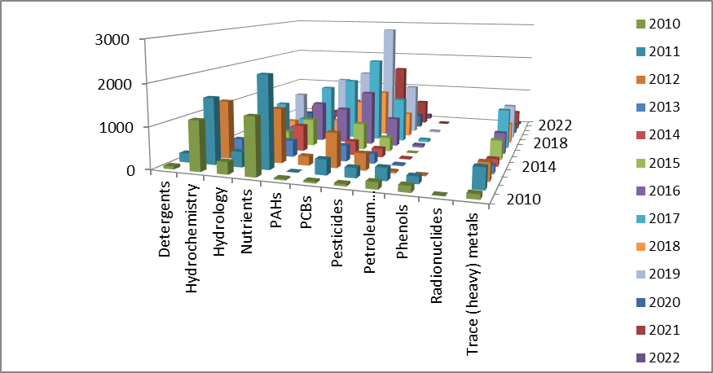
Figure 6.1 - Distribution of the number of samples by parameter groups and years (water)

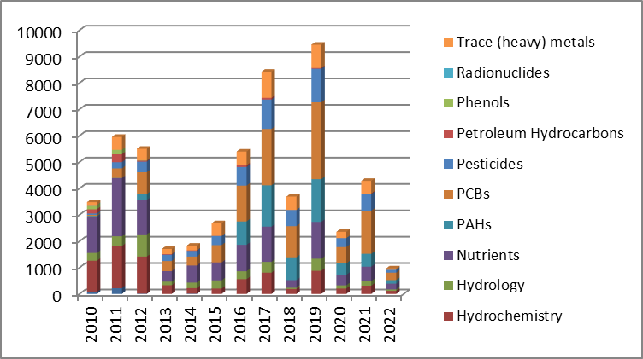
Figure 6.2 - Total numberof samples for each parameters group (water)

Table 6.4 – Statistics of the number of samples by parameter groups and by years (sediment)

Ukraine | SampleType- sediment
ParameterGroup/  Year | 2010 | 2011 | 2012 | 2013 | 2014 | 2015 | 2016 | 2017 | 2018 | 2019 | 2020 | 2021 |  |  |  | 2022
Hydrochemistry |  | 84 | 41 | 34 | 20 | 56 | 64 | 88 | 24 |  |  | 48
PAHs | 204 | 289 | 374 |  |  |  | 416 | 833 | 442 | 702 | 216 | 198
PCBs | 32 | 489 | 707 | 723 | 266 | 684 | 621 | 1081 | 614 | 1344 | 312 | 888
Pesticides | 52 | 495 | 350 | 415 | 154 | 359 | 324 | 564 | 312 | 582 | 168 | 310
Petroleum Hydrocarbons | 47 | 45 | 43 | 37 | 15 | 26 | 39 | 49 | 24 | 24 | 12 | 24
Phenols | 43 | 42 | 41 | 34 | 10 | 19 | 39 | 44 | 24 | 39 | 12 | 24
Radionuclides |  |  | 4
Trace (heavy) metals | 300 | 492 | 422 | 352 | 180 | 330 | 348 | 588 | 312 | 504 | 132 | 288 | 24

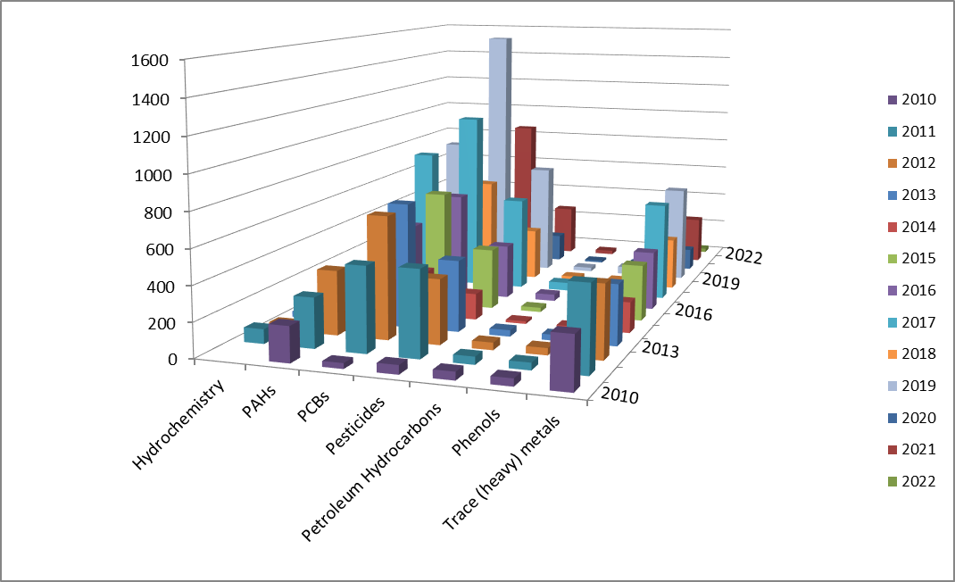

Figure 6.3 - Distribution of the number of samples by parameter groups and years (sediment)

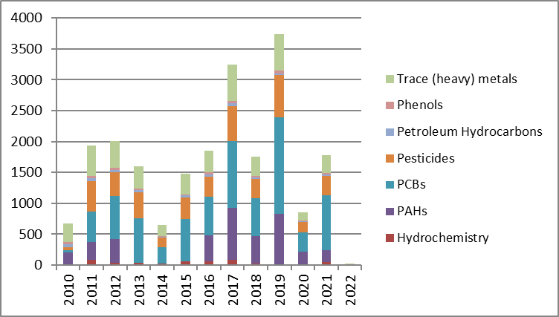
Figure 6.4 - Total number of samples for each parameters group (sediment)

Table 6.5 – Statistics of the number of samples by parameter groups and by years (biota)

Ukraine |  | SampleType-Biota
ParameterGroup/Year | 2012 | 2013 | 2014 | 2015 | 2016 | 2017 | 2018 | 2019 | 2020 | 2021 | 2022
PCBs | 160 | 361 | 320 | 128 | 414 | 529 | 120 | 186 | 234
Pesticides | 88 | 209 | 176 | 69 | 216 | 276 | 48 | 84 | 126
Trace (heavy) metals | 106 | 193 | 176 | 70 | 190 | 242 | 44 | 77 | 121
PAHs |  |  |  |  | 288 | 368 | 64 | 102 | 162

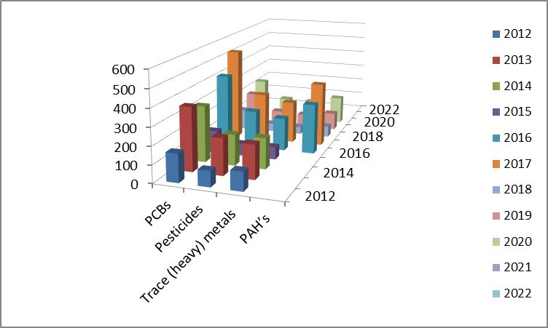
Figure 6.5 - Distribution of the number of samples by parameter groups and years (biota)

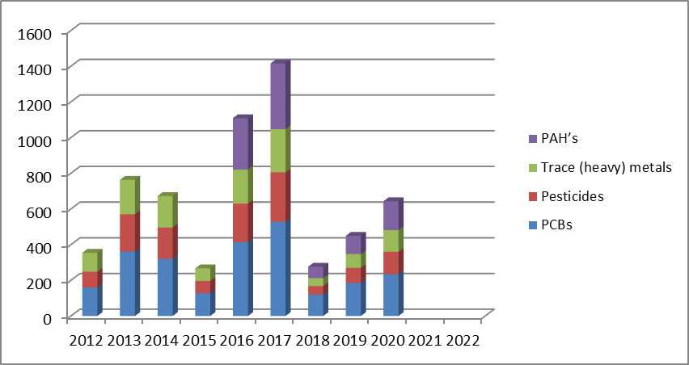
Figure 6.6 - Total number of samples for each parameters group (biota)

